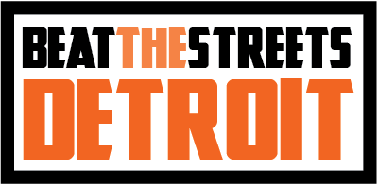
39500 High Pointe Blvd, Novi, MI 48375

Diversity Policy as of 5 January 2020

Beat the Streets Detroit is committed to cultivating and preserving a culture of diversity, equity, and inclusion within the sport of wrestling and our larger community.
Human capital is our most valuable asset. The collective sum of our individual differences, life experiences, knowledge, inventiveness, innovation, self-expression, unique capabilities and talent that our team members constitutes a significant part of not only our culture, but our reputation and program’s achievement as well.
We embrace and encourage our differences in age, color, disability, ethnicity, family or marital status, gender identity or expression, language, national origin, physical and mental ability, political affiliation, race, religion, sexual orientation, socio-economic status, veteran status, and other characteristics that make the Beat the Streets Detroit team unique.
Beat the Streets Detroit’s diversity initiatives encourage and enforce:
- Respectful communication and cooperation between all team members.
- Teamwork and participation, permitting the representation of all groups and perspectives.
- Work/life balance through flexible schedules to accommodate each team member’s varying needs.
- Our collective contributions to the communities we serve to promote a greater understanding and respect for the diversity.
All board members, coaches, tutors and volunteers of Beat the Streets Detroit have a responsibility to treat others with dignity and respect at all times. All team members are expected to exhibit conduct that reflects inclusion during time spent working on the Beat the Streets Detroit program whether at practice or elsewhere. Annual diversity awareness training will be held each year in conjunction with our Annual Coaches and Tutors meeting to enhance all team members’ knowledge to fulfill this responsibility.
Any BTSD team members found to have exhibited any inappropriate conduct or behavior against others may be subject to disciplinary action.
Team members who believe they have been subjected to any kind of discrimination that conflicts with the Beat the Streets Detroit Diversity Policy should seek assistance from the BTSD Board Member with whom they feel the most comfortable.

